Power BI Automotive Dashboard

Project Overview
The Automotive Dataset represents data about various car models and their performance characteristics. It includes features such as miles per gallon (mpg), engine displacement, horsepower, weight, acceleration, model year, and origin. The dataset is analyzed using Power BI to create an Automotive Cars Analysis Dashboard that explores car performance, efficiency, and design trends across different manufacturers and regions.

Dataset Description
The dataset contains car performance details for 392 car models, providing technical specifications and efficiency indicators.
Fields:
car name, mpg, cylinders, displacement, horsepower, weight, acceleration, model year, origin
Description:
Each record represents a unique car model and its attributes, such as engine power, weight, fuel efficiency, and design origin.
Purpose:
Used to analyze fuel efficiency, power-to-weight ratio, and performance variations by region and year.

Business Objectives
The main objective of this dashboard project is to analyse Home Loan performance and gain actionable business insights that support data-driven decision-making. The key goals include:
- Analyse car performance and fuel efficiency across different parameters like cylinders, horsepower, and weight.
- Identify relationships between vehicle weight, acceleration, and fuel economy (MPG).
- Compare regional car characteristics based on the origin field (1 = USA, 2 = Europe, 3 = Japan).
- Understand trends in engine specifications over the model years.
- Create a dynamic Power BI dashboard that highlights KPIs and performance insights visually.

Key Business Questions
- What is the average MPG, weight, horsepower, and displacement across all vehicles?
- How does the number of cylinders affect average MPG and horsepower?
- Which region (origin) produces cars with higher fuel efficiency or lower weight?
- How have vehicle specifications (MPG, horsepower, displacement) evolved by model year?
- What are the key influencing factors impacting fuel efficiency (MPG)?
- Which variables are most correlated with acceleration and vehicle performance?

Tools & Techniques
Power BI Desktop
- Microsoft Power BI
- Data Cleaning and Transformation using Power Query
- Calculated Columns and DAX Measures
- KPI Cards for Average Weight, Displacement, Horsepower, MPG, and Acceleration
- Visualizations including Funnel Chart, Bar Chart, Line Chart, and Key Influencers Visual
- Interactive Filters and Slicers for Cylinder Count, Model Year, and Origin

Deliverables :
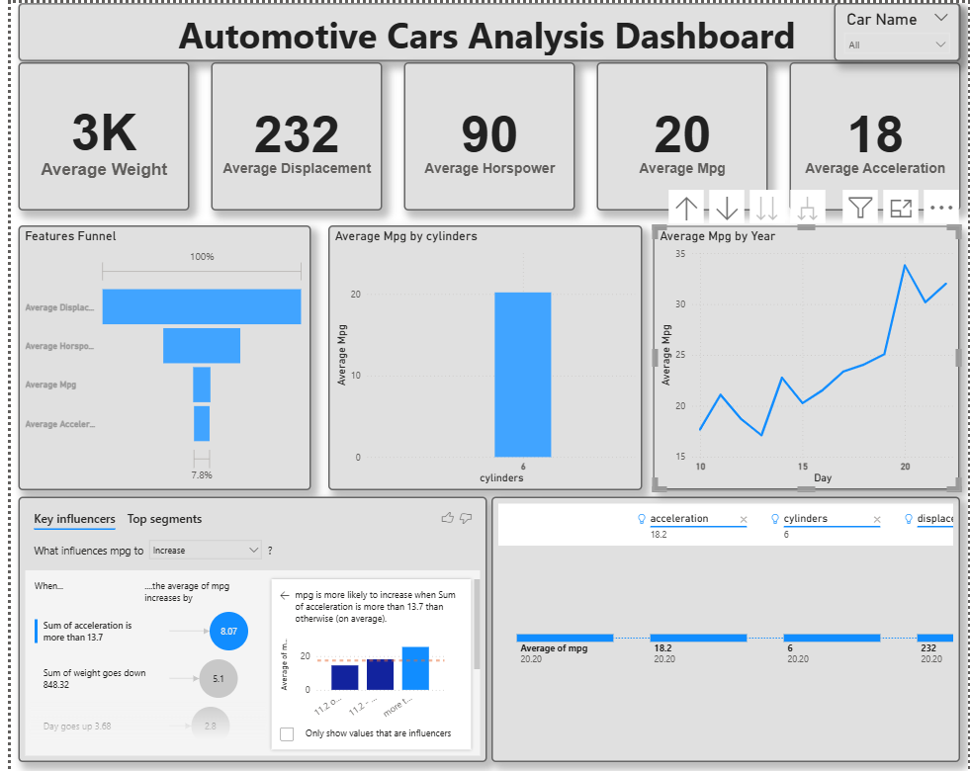
Insights :
- The average car weight is approximately 3,000 lbs, with an average displacement of 194 and horsepower of 104.
- Cars with fewer cylinders (4-cylinder engines) have higher average MPG, showing better fuel efficiency compared to larger engines.
- Average MPG has increased consistently over model years, suggesting improvements in design and engine efficiency.
- The funnel visualization indicates a decreasing trend from weight to acceleration, showing how heavier vehicles require more power and have lower acceleration rates.
- Key Influencers analysis shows that lower weight and fewer cylinders are major factors contributing to higher fuel economy.
- Acceleration and weight are inversely related – as vehicle weight increases, acceleration tends to decrease.
- Cars with higher horsepower achieve better acceleration but lower fuel efficiency.

Future Enhancements:
- Include additional data fields like car manufacturer, fuel type, and transmission mode for deeper analysis.
- Add predictive analytics using regression to estimate fuel efficiency for new models.
- Integrate real-time data or updated car datasets for dynamic comparison across recent years.
- Develop an advanced KPI comparison dashboard for performance benchmarking by brand or region

